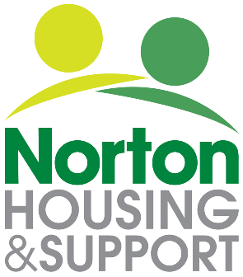

Oasis Well-Being Project Referral Form
The Well-being Project provides weekly social drop-ins and access to individual support on Tuesday mornings and Friday afternoons. The project is open to referrals from adults (18 years of age or over) who live in Leicester and have ongoing mental health needs and may be especially socially isolated and / or struggle to access support elsewhere. The Project is funded by Carlton Hayes. If you are interested in referring yourself, or someone you know, to the Project, please kindly complete the short referral form below.

Name: DOB: DOB:
Address:
Telephone:
Is this a self referral? Yes or No
Name & contact details of person making this referral if not self:
Which of our 2 Weekly Drop-ins you would like to attend? (you may opt for either one or both)

Tuesday 10am-12pm. Friday 2-4pm -The Regent Sports and Social Club.

Date:
Well-Being Project Client Referral Form
How would you benefit from attending the Well-being project?
Please describe your mental health: (diagnosis, symptoms, difficulties you experience)
Please describe your physical health: (diagnosis, symptoms, difficulties you experience)
Are there any risk factors that we need to know about or anything else you think might be relevant for us to know?
Please return this form to: Norton Housing and Support, 107 Newport Street, Leicester, LE3 9FU or email to info@nortonhousingandsupport.org.uk

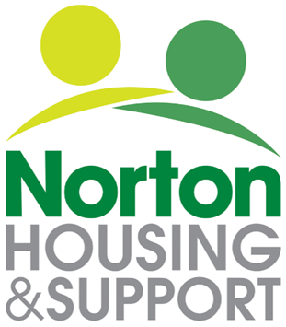

Equality and Diversity Monitoring

Norton Housing and Support strive for high standards, both as employers and as providers of services. In so doing, we recognise the need to encourage diversity and wholeheartedly support a policy of equal opportunities in all areas of our work and responsibilities.

The purpose of this form is to help us monitor how well we are doing in attracting people from as wide a range of backgrounds as possible. The information will remain confidential and will only be used for statistical purposes.

As a result of this monitoring, we may find we need to make changes to the way in which we operate or the services we offer.

Please complete the form as fully as you feel able. However, if you do not want to answer a particular question, please tick this option.

Thank you.

Equality and Diversity Monitoring Form

(please tick appropriate box)

Sex and gender identity

Is the gender you identify with the same as your sex registered at birth?
Yes

No

Prefer not to say

What is your sex?

Female

Male

Prefer not to say

If the gender you identify with is not the same as your sex registered at birth, please write in the gender you identify as:

Age
18-30 |  | 31-40 |  | 41-50
51-60 |  | 60+ |  | Prefer not to say

Do you consider yourself to have a disability or health condition?

Yes |  | No |  | Prefer not to say  If you have answered yes, please indicate the type of impairment which applies to you. People may experience more than one type of impairment.  Mental health condition such as schizophrenia, bipolar disorder or depression  Physical impairment such as mobility issues which may mean using a wheelchair or crutches.  Sensory impairment such as being blind/ having a visual impairment or deaf / hearing impairment.  Learning disability such as Down’s syndrome or dyslexia or Cognitive impairment such as autism or a head injury.  Long standing illness or health condition such as cancer, HIV, diabetes, chronic heart disease or epilepsy.  Do not wish to say

What is your ethnicity?

Ethnic origin is not about nationality, place of birth or citizenship. It is about the group to which you perceive you belong. Please tick the appropriate box

Asian or Asian British

Indian

Pakistani

Bangladeshi

Chinese

Prefer not to say

Any other Asian background, please write in:

Black, African, Caribbean or Black British
African

Caribbean

Prefer not to say

Any other Asian background, please write in:

Mixed or Multiple ethnic groups

White and Black Caribbean

White and Black African

White and Asian

Prefer not to say

Any other Mixed or Multiple ethnic background, please write in:

White

English

Welsh

Scottish

Northern Irish

Irish

British

Gypsy or Irish Traveller

Prefer not to say

Any other White background, please write in:

Other ethnic group

Arab

Prefer not to say

Any other ethnic group, please write in:

What is your sexual orientation?

Heterosexual |  | Gay |  | Lesbian |  | Bisexual
Asexual |  | Pansexual |  | Undecided |  | Prefer not to say
If you prefer to use your own identity, please write in:

What is your religion or belief?

No religion or belief |  | Buddhist |  | If other religion or belief, please write in:
Christian |  | Hindu
Jewish |  | Muslim
Sikh |  | Prefer not to say

