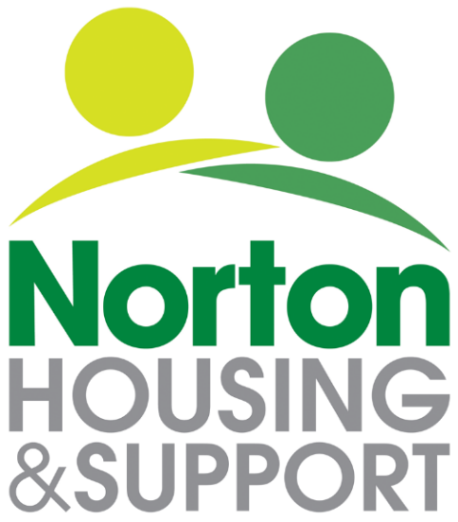
Service User Privacy Notice - Wellbeing Club
(How we use your information)
The Data Controller is: Norton Housing and Support Ltd (NH&S), 107 Newport Street, Leicester, LE3 9FU 0116 2538541 info@nortonhousingandsupport.org.uk

Information About You

The information you provide us with may be used to contact you about the wellbeing club service, monitor uptake and assist you in an emergency or if we have concerns about your welfare. The information we collect includes your name contact details and date of birth. It also includes the name of someone we could contact for you in an emergency, any health issues you feel we should know about and contact details of others involved in your care – including your GP.

As part of our monitoring systems, any accidents or incidents that you are involved in whilst using our services will be recorded, as will any safeguarding concerns that staff become aware of.

What we do with this information is controlled by the General Data Protection Regulations and you have the right to:

1. Know how we collect and use your date.
2. See what information we hold (called making a “Subject Access Request”)
3. Get inaccurate information corrected
4. In some circumstances, have the information we hold about you deleted.
5. In some circumstances, restrict how we use your information.
6. Ask us to share your data.
7. Ask us to stop processing your data—called “the right to object”
8. Make a Complaint
The law says that when personal data about you is processed, the organisation processing it must have clear reason for doing this, called a ‘lawful basis’. Our lawful basis for processing your personal data is as that it is necessary for our legitimate interest i.e. to provide drop in services. In order to process ‘special’ category data, such as information about your health, organisations must satisfy certain additional conditions. Our condition for processing special category personal data is that the processing is carried out in the course of our legitimate activities as a not-for-profit body (a registered Charity)

What if I don’t provide you with the information you request?

If we do not have enough information, we may not be able to provide you with services or your health and safety may be put at risk.

Storing this information
Your personal data is stored:

- In paper format in a locked cupboard at the head office, 107 Newport Street, Leicester, LE3 9FU.
- Electronically, on the Norton Housing and Support head office server. Access to this is restricted and passwords are in use.

Please rest assured that your data is only accessed by Norton Housing and Support staff in the course of providing you with services. Staff receive training and a full induction outlining their responsibilities to abide by our data protection and confidentiality procedures.
Retention

Your information will be retained and regularly updated whilst you are using the service. If you inform us that you will no longer be using the service or once you have not used the service for six months, you will be considered to have left and your information will be securely destroyed.

Who We Share Your Information With
We do not routinely share your information with anyone, unless you specifically request us to. Anonymised information may be shared with our funders.

If we are concerned that you or another person may be at risk of harm, we may share this information with the people you have named on this form – for example your GP or your CPN, as well as with adult social care. We may also share it with the police if necessary for the reporting, detection or prevention of crime.

As part of our marketing activities we may publish photographs, and anonymised quotes from or case studies about our Service Users– this includes sharing them online. This will only be done with your consent.

Your Rights

To make a request for your personal information, if you believe any of the data we hold about you is inaccurate, or you wish to have it erased, please contact the Senior Administrator on info@nortonhousingandsupport.org.uk or 0116 2538541.

Complaints

If you have a concern about the way we are collecting or using your personal data, please let us know and we will be happy to address your concerns, please contact the Senior Administrator on info@nortonhousingandsupport.org.uk or 0116 2538541.

You may also utilise our Comments, Suggestions and Complaints Process. If you are unhappy with the way we handle a complaint about how we process, store or share your data, you may contact the Information Commissioner’s Office – find out more at https://ico.org.uk/concerns/

Data Breaches
The law requires NH&S to report any data breach to the relevant authority within 72 hours.
Review
This Privacy Notice will be reviewed periodically - This version – June 2022

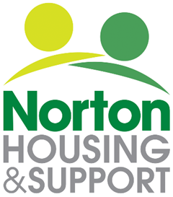

Service User Privacy Notice Confirmation

I confirm that I have been given and read The Service User Privacy Notice (Wellbeing Club) June 2022 version.

Name: ___________________________

Signed____________________________

Date: ___________________________

