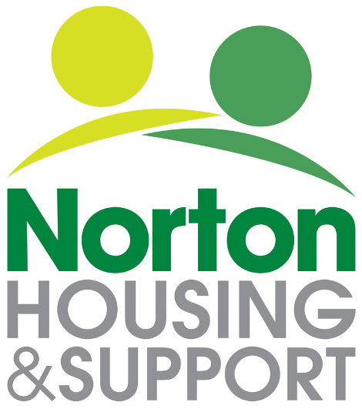

APPLICATION FOR WOMEN’S SCHEME

Norton Housing and Support has two group living accommodation services for vulnerable young women, including those who are pregnant or have a young child. Support is provided Monday to Friday by an Intensive Housing Management Officer.

The scheme aims to provide women with a stable living environment whilst they begin the process of rebuilding their lives and to support them to secure independent accommodation.

This form can be completed by you or with the help of someone who knows you and your support needs e.g. your Social Worker or Key Worker. However, it is important that you read the form carefully and sign the declaration at the end.

We will also need any available supporting information such as a Risk Assessment, Social Care Assessment or Support Plan.

Please note that:

- We cannot process applications without a signature from the applicant.

- All Questions must be answered in full.

- The application may not be considered if any areas of the form have not been completed

ABOUT ME

Full Name DOB: Age:

Are you a UK or EEA Citizen? Yes ☐ No ☐

(If no, staff must complete the additional checks before a decision for accommodation can be made)

Current Address:

Tel:

Correspondence Address (If different)

Tel:

NI Number:

Main Language:

Any Cultural or Religious Needs:

Any Communication Needs:

Preferred Communication Method:

ABOUT MY SUPPORT NETWORK
Yes No
Do you have support from a health/social care professional e.g. Social Worker, ☐ ☐ midwife etc.? If so, please give name, address and contact details.

Name:
Address:
Telephone:
Email:

Are you homeless / at risk of homelessness? Yes No

☐ ☐

Why do you need to move?

Yes No

Do you have a live housing application? ☐ ☐

If yes: Band:
Housing Application Number

Yes No

Do you have a GP? ☐ ☐

If so, please give name, address and contact details.

Name:
Address:
Telephone:

Yes No

Do you have support from anyone else? ☐ ☐
E.g. friends, family, voluntary sector service, advocate.
If so, please give name, address and contact details.
:
:

MY HEALTH AND WELLBEING

Physical Health. Please Tick Box
Which Applies to You

- Physical health is very poor ☐

- Some physical health problems requiring treatment ☐

- Physically fit and well. ☐

Please give details of any physical health issues including any medication taken:

Mental Health Please Tick Box
Which Applies to You

- Mental health causes concern everyday ☐

- Mental health causes concern most days ☐

- Mental health causes concern some of the time ☐

- Cope quite well with mental health most of the time ☐

- Feel that mental health is quite stable ☐

Please give details of your mental health issues and the impact on your daily life.

Substance Misuse Yes No

Have you ever used illegal substances? ☐ ☐
If yes please describe.

:
:

Yes No

Do you feel you have an issue with alcohol? ☐ ☐
If yes please describe.

:
:

Are you currently receiving or have received support for drug or alcohol use? Yes No

☐ ☐

If yes, please describe.

Have you been convicted of a criminal offence or are you subject to a current police investigation or are working with the probation service?
If yes please give details? Yes No

☐ ☐

FINANCIAL SITUATION Yes No

Are you receiving or entitled to Housing Benefit? ☐ ☐

Do you receive ESA? ☐ ☐
Do you receive DLA or PIP? ☐ ☐

Do you receive Universal Credit? ☐ ☐

Do you currently manage your own finances? ☐ ☐

Comments/Issues:

RISK FACTORS

Please note that if applicable, we will need a copy of a recent (last six months) risk assessment before we can process your application.

Please answer the following questions in as much detail as possible:

Do you feel your behaviour has ever put others at risk? e.g. verbal or physical aggression.

Do you feel your behaviour has ever put you at risk? e.g. self-neglect or impulsive behaviour.

Have you ever been a victim of domestic violence? Yes ☐ No ☐

If yes, please describe

How do you feel Norton Housing and Support can help you?

ACCESS TO DEPENDENTS
Yes No

Do you have any children? ☐ ☐

Do you have access to any children? ☐ ☐

Are you pregnant? ☐ ☐

Is there any Child Protection Order, or risk concerns in this area? ☐ ☐

If you have answered yes to any of the above, please provide additional information

(Due dates, dates of birth of any children)

Form completed by:
Print Name:

If not the applicant, please give contact details.

How We Use Your Information

The information on this form has been collected by Norton Housing and Support Ltd of 107 Newport Street, Leicester, and will be used in accordance with the relevant data protection legislation. In particular, it will be treated in the strictest confidence and processed lawfully and fairly to ensure that your housing and/or support needs are identified .For more details on how we use your information, please see our Applicant’s Privacy Notice, which is available on our website www.nortonhousingandsupport.org.uk

Applicant’s Declaration

As part of our Application process, the information given above may be discussed with the third parties named on the application form (your GP, Midwife, Social Worker etc)

PLEASE SIGN BELOW TO CONFIRM YOU WISH TO BE REFERRED TO OUR SERVICES AND AGREE TO NORTON HOUSING AND SUPPORT CONTACTING YOUR GP, MIDWIFE OR ANYONE ELSE DETAILED ON THIS FORM FOR ADDITIONAL INFORMATION.

Signed ……………………………………………… Date ………………………………….……...………

Please return your application along with the Equality and Diversity Monitoring Form to:
Norton Housing and Support, 107 Newport Street, Leicester, LE3 9FU.
Or email a scanned, signed version to info@nortonhousingandsupport.org.uk

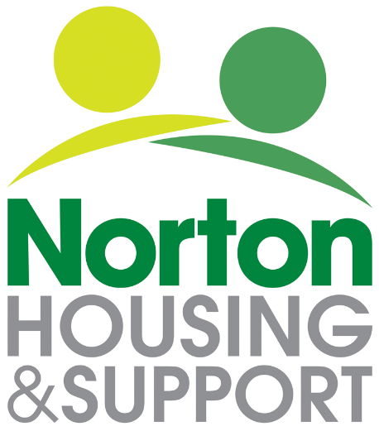

Equality and Diversity Monitoring

Norton Housing and Support strive for high standards, both as employers and as providers of services. In so doing, we recognise the need to encourage diversity and wholeheartedly support a policy of equal opportunities in all areas of our work and responsibilities.

The purpose of this form is to help us monitor how well we are doing in attracting people from as wide a range of backgrounds as possible. The information will remain confidential and will only be used for statistical purposes.

As a result of this monitoring, we may find we need to make changes to the way in which we operate or the services we offer.

Please complete the form as fully as you feel able. However, if you do not want to answer a particular question, please tick this option.

Thank you.

please select appropriate boxes

AGE:
☐ 18-21
☐ 22-25
☐ 26-29
☐ 30+

RELIGION / BELIEF:

☐ Atheist
☐ Bahai
☐ Christian
☐ Hindu
☐ Jain
☐ Jewish
☐ Muslim
☐ Rastafarian
☐ Sikh
☐ Zoroastrian
☐ No belief
☐ Other, please state:
☐ Rather not say

ETHNIC ORIGIN / ETHNICITY:

Black / Black British:

☐ Black / Black British - Caribbean
☐ Black / Black British - African
☐ Black / Black British - Other – please state:

Dual / Multiple / Mixed:

☐ Dual / Multiple / Mixed - African and White
☐ Dual / Multiple / Mixed - Asian and White
☐ Dual / Multiple / Mixed - Caribbean and White
☐ Dual / Multiple / Mixed - Other – please state:

White:

☐ White - British
☐ White - Irish
☐ White European
☐ White - Other -please state:

☐ Chinese
☐ Gypsy / Romany / Irish Traveller
☐ Other, please state:
☐ Rather not say

SEXUAL ORIENTATION:

☐ Bisexual
☐ Heterosexual
☐ Lesbian
☐ Gay
☐ Other, please state:
☐ Rather not say

DISABILITY:

Under the Equality Act 2010, a person is considered to have a disability if she/he has a physical or mental impairment which has a substantial and long-term adverse effect on her/his ability to carry out normal day-to-day activities.

I consider myself to be:

☐ Disabled
☐ Non-disabled
☐ Rather not say

