

Healthy Living Focus

Seasonal Affective Disorder!



* Making the most of natural light can be a big mood booster.
* Go for a daily walk after sunrise, and before sunset.
* Tidy the garden during daylight hours.
* Even gentle exercises like swimming and yoga can be really beneficial to lifting your mood.

**How can I help myself?**

**Following some simple self care tips can help to ease the stress and worries of a low mood**

* **Keep a diary-making a note of the weather as well as your mood each day.**
* **Spend time in nature- visiting a green space can be really mindful.**
* **Get enough sleep – this helps to regulate your body clock.**
* **Go easy on yourself- set small and realistic goals.**

Exercise in natural light

**Youre not alone if SAD is causing you to crave carbs. Fuel these cravings with healthy carbs such as sweet potato, for their mood boosting properties.**

Healthy Living Goal

Maximize your time outdoors. Why not walk to the local park? or go on foot instead of catching the bus?

Food and Mood

Enjoy winter stables such as root vegetables, hearty soups, and stews.

Easy Meals: Plan ahead for Winter by batch cooking your favourite meals and storing them in the freezer for days when you are lacking energy.

Eat at regular times to maintain blood sugar levels.

* Visit <https://www.thelist.com/89020/foods-help-deal-sad/> to find out about foods to help you deal with SAD.

What is Seasonal Affective Disorder?

SAD is a type of depression experienced during some seasons in particular, because of certain types of weather, or even the effects of daylight. It can cause low mood for long periods of time and effect everyday health.

It could be caused by one or more of the below, or have no reason at all!

* Less daylight hours and little natural light
* Changing temperatures and seasons
* Stressful times of the year, ie. Christmas.
* Sleep hormones and a disrupted body clock

Hello and welcome to this week’s healthy living focus. With winter fast approaching; changes in weather and daylight hours, this edition will focus on at a certain type of depression known as Seasonal Affective Disorder (SAD). We will look at ways to manage phsyical health when living with SAD, share self care tips, as well as tips to get the most out of the few daylight hours we have in Winter.

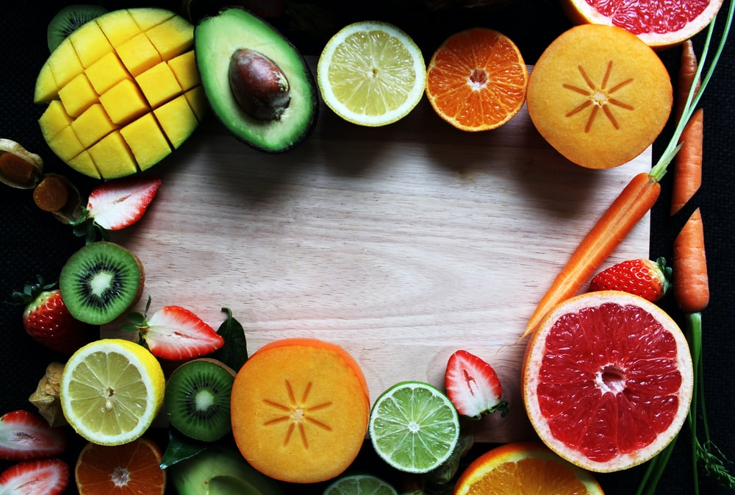

Sweet Potato and Salmon with Brocolli

Method

**Meet our Healthy Living Coordinator, Claire. Who is responsible for our newsletter and healthy living project.**

If you have any queries, would like to suggest a feature for our future newsletters, or would like support and advice around issues raised here, please contact Claire at [healthyliving@nortonhousingandsupport.org.uk](mailto:healthyliving@nortonhousingandsupport.org.uk)

**Recipe Of The Week**

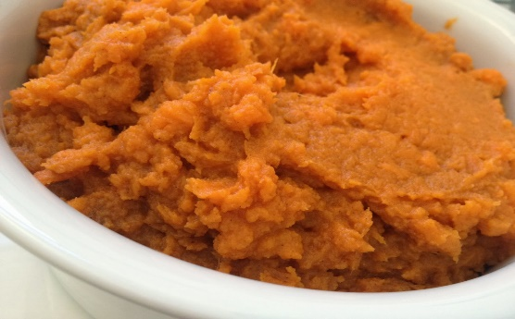

1. Heat oven to 200C/180 fan/ gas 6 and line a baking tray with parchment paper.
2. Mix together 1/2 tbsp sesame oil, soy sauce, ginger, garlic and honey.
3. Put the sweet potato wedges into a glass bowl with the lime wedges. Cover with cling film and microwave on high for 12-14 mins until completely soft.
4. Spread the broccoli and salmon out on the baking tray. Spoon over the marinade and bake in the oven for 10-12 mins.
5. Remove the sweet potato bowl from the microwave, and discard the lime wedges. Roughly mash the sweet potato using a fork and then in the remaining sesame oil, and the chilli if using.
6. Divide between plates, along with the salmon and broccoli.

Healthy Living Tips

* Salmon and sweet potatoes are great for fighting a low mood, as they provide both healthy carbohydrates, and vitamin D, which can be lacking during winter months.

1 ½ tbsp sesame oil

1 tbsp low-salt soy sauce

3cm piece ginger, grated

1 garlic clove, crushed

1 tsp honey

2 sweet potatoes, cleaned and cut into wedges (leave the skin on)

1 lime, cut into wedges

2 boneless skinless salmon fillets

250g purple sprouting broccoli, or tenderstem brocolli

1 red chilli, thinly sliced with the seeds removed (optional)

Ingredients