Crunchy Wholegrain Nuggets

International Whole Grain Day is on the 16th November 2021. Eating enough wholegrains is beneficial to lowering cholesterol, keeping the heart healthy, and forms part of a varied and nutritional diet! Using wholegrain cereal, and baking instead of frying, gives these crunchy nuggets a healthy living thumbs up!
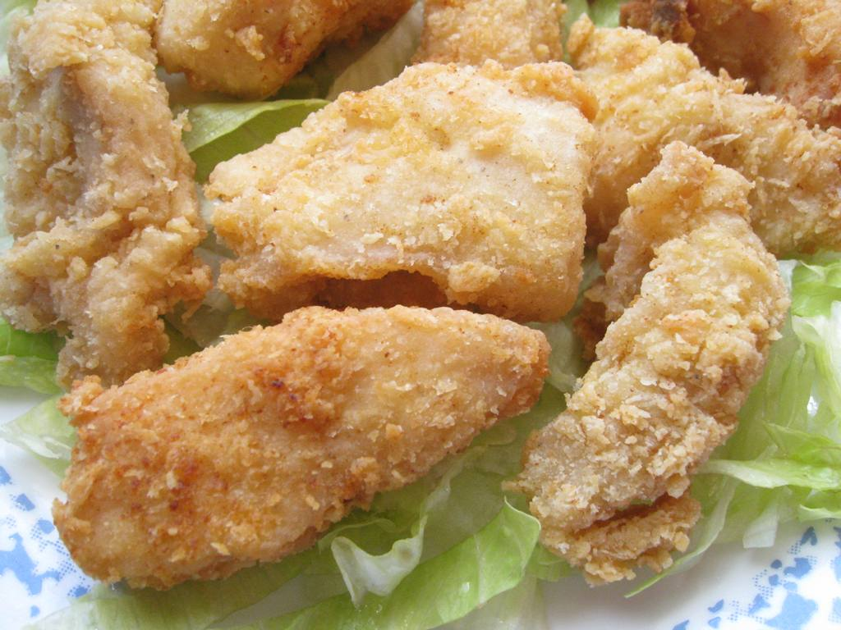
Ingredients
- 2 cups Cheerios®
- 0.5 teaspoon pepper
- 60ml semi-skimmed milk
- 2 tablespoons honey
- 1 tablespoon mustard
- 450g boneless, skinless chicken breasts or thighs, cut into 3.5 cm pieces
- Cooking spray

Method
- Heat the oven to 200° C.
- Spray a 33 x 23cm baking tray with cooking spray.
- Finely crush the Cheerios®.
- Stir together the Cheerios® and pepper; set aside.
- In a medium bowl, stir together milk, honey and mustard.
- Dip chicken into the milk mixture; and then coat with cereal mixture.
- Place the chicken on the baking tray, and lightly spray the nuggets.
- Bake for 20 to 25 minutes or until the outside is golden and the chicken is no longer pink.

