

Healthy Living Focus

Headaches



Sleep Soundly

Poor sleeping habits such as lack of sleep, or even too much sleep can trigger a migraine or tension headache.

Sleep helps keep your immune system strong, fights off depression and anxiety, and promotes relaxation. Sticking to a regular sleep schedule means going to bed and waking up at the same time every day.

**Quit Smoking!**

**Quitting smoking can dramatically reduce the frequency of headaches, as well as improving lung health and reducing the risk of serious conditions such as lung cancer.**

* **Stress:** knowing how to handle stress can improve the frequency of headaches. Maybe enjoy a warm bath or read a book to relax.
* **Poor Posture**: Is your spine straight? Are your shoulders hunched?

By making some adjustments to your posture, it may help reduce the frequency of migraines and tension headaches.

Healthy Living Goal

This week aim to improve your posture by sitting up straight, especially when watching TV or using a Computer.

Preventing Headache and Migraine Triggers

Eat regular and balanced meals

Skipping meals makes you hungry, which can trigger a migraine. Aim to eat lots of fruit, vegetables and wholesome foods such as jacket potatoes and brown rice, lean meat and fish. Eat breakfast, lunch, and dinner, with a couple of healthy snacks inbetween.

Avoid Certain Foods

Some foods can trigger a tension headache or migraine.

If you know which foods are a problem for you, limit how often you eat them… common culprits are:

**Alcohol**

**chocolate**

**cheese**

**caffine; in things such as coke and coffee**

Hello and welcome to this week’s healthy living focus, in this edition we are looking at ways to keep headaches and migraines at bay. By avoiding things you know that may set off a migraine or headache and creating healthy habits, you can actually help to reduce the amount of migraines or headaches you experience.

* Visit <https://www.nhs.uk/conditions/migraine/> to read about further migraine support and when to seek medical advice.

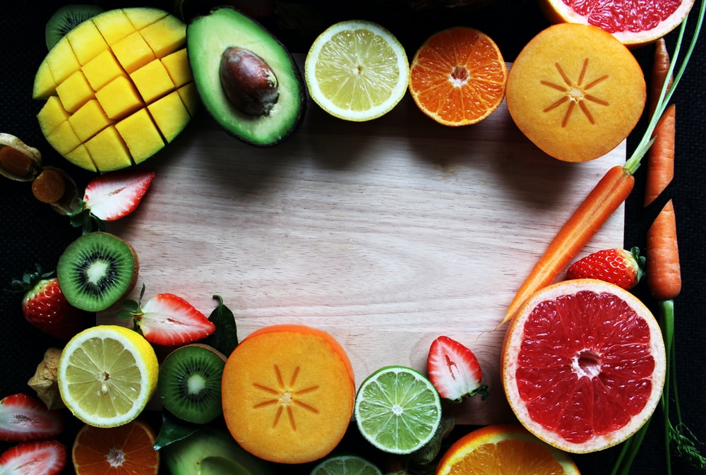

**Recipe Of The Week**

Banana and Spinach Smoothie

**Meet our Healthy Living Coordinator, Claire. Who is responsible for our newsletter and healthy living project.**

If you have any queries, would like to suggest a feature for our future newsletters, or would like support and advice around issues raised here, please contact Claire at [healthyliving@nortonhousingandsupport.org.uk](mailto:healthyliving@nortonhousingandsupport.org.uk)

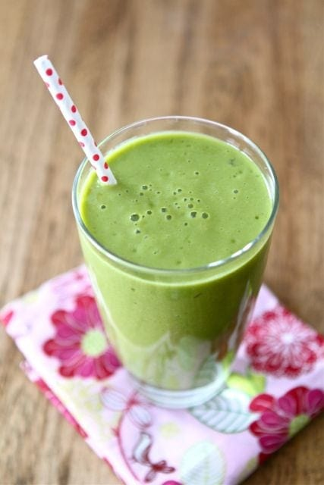

Method

1. Measure out the milk, and add to the blender.
2. Add in all other ingredients and blitz until super smooth.
3. pour into a tall glass and enjoy!

you could add in a teaspoon of peanut butter, extra strawberries, or a pinch of cinamon for something different!

Healthy Living Tips

This smoothie has anti-inflammatory ingredients as well as spinach which is rich in magnesium. It can be enjoyed as a tasty ‘on the go’ breakfast, or as a healthy snack.

The best part is; you cant even taste the spinach!

20g spinach leaves/ 3 cubes if frozen

1 banana peeled

25g of raw oats

250ml of coconut milk or soya milk

Ingredients