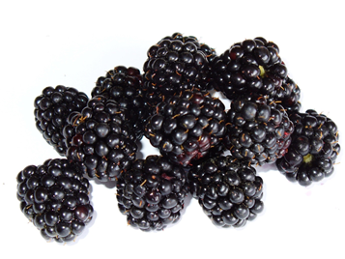
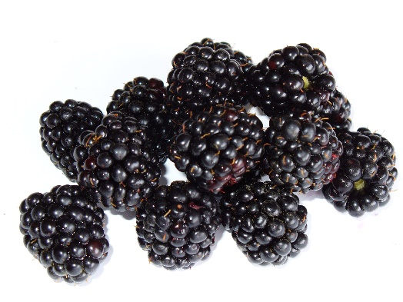
Fresh Blackberries
Early September is the perfect time for enjoying blackberries, whether you’ve picked them yourself or bought from the shop!

Stewing blackberries is a simple way to cook them…
- Carefully wash berries and drain.
- Place berries in saucepan. (approx. 250g)
- Add 75ml water, cover, and heat slowly; simmer berries for about 15 minutes.
- Shake pan or stir gently to prevent berries from sticking.
- Add 1tbsp granulated sweetener and heat 2-3 minutes longer.
- Remove from heat.
- Serve warm or chilled. Enjoy over natural yoghurt, added to porridge or with a scoop of ice cream.

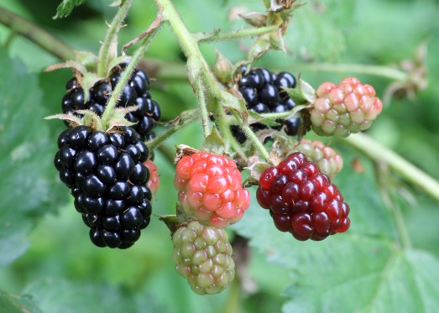
Why not enjoy blackberries as part of a tasty salad?
Simply toss in a bowl with salad leaves, cucumber, cherry tomatoes, sliced beetroot and 50g of firm goat’s cheese.
For an extra treat serve with homemade croutons made with 1cm cubes of bread tossed in a little oil and baked in the oven for 8 minutes or until golden!

