

Healthy Living Focus

Healthy Blood Pressure!

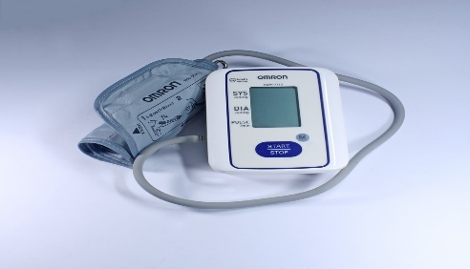

Ways to lower blood pressure

Foods to eat for a healthy blood pressure

Wholegrains; such as rice, bread, or pasta. How about a tasty skin on jacket potatoe with reduced salt baked beans?

Fruit; why not try ‘in season’ blackberries?

Vegetables; how about a side of greens including broccoli, peas and cabbage?

Low fat dairy products or dairy alternatives; such as cottage cheese, skimmed milk, or soya yoghurt.

Healthy Living Goal

Try to make time throughout September to get your free blood pressure check

Hello and welcome to this week’s healthy living focus, in this edition we are looking at blood pressure. Having high blood pressure can cause lots of health problems, but by having an understanding of your own blood pressure, and making healthy lifestyle changes, we can strive to keep blood pressure numbers in check.

* Visit <http://www.bloodpressureuk.org/> for further tips and advise on how to lower blood pressure.
* 1 in 3 adults have high blood pressure.
* 1 in 2 strokes and heart attacks are the result of high blood pressure.
* 6 million people in the UK are living with high blood pressure and don’t know it!

**The science bit!**

**An ideal blood pressure is under 120/80mmHg**

* Exercising for 30 minutes a day goes a long way to keeping blood pressure under control.
* Eat a low salt diet; avoid processed meals and don’t add salt to food.
* Reducing stress can help to lower blood pressure. Why not try a mind and body exercise such as yoga?

Blood Pressure UK’s ‘Know Your Numbers’ Campaign

Throughout September Blood pressure UK are offering FREE blood pressure checks at

Haymarket Health, 1st floor, Kemble Gallery, Haymarket Shopping Centre, LE1 3YT

Opening hours

Monday: 12.00 - 18.00

Tuesday: 12.00 - 18.00

Wedensday: 12.00 - 18.00

Thursday: 12.00 - 18.00

Friday: 12.00 - 16.00

Saturday: Closed

Sunday: Closed

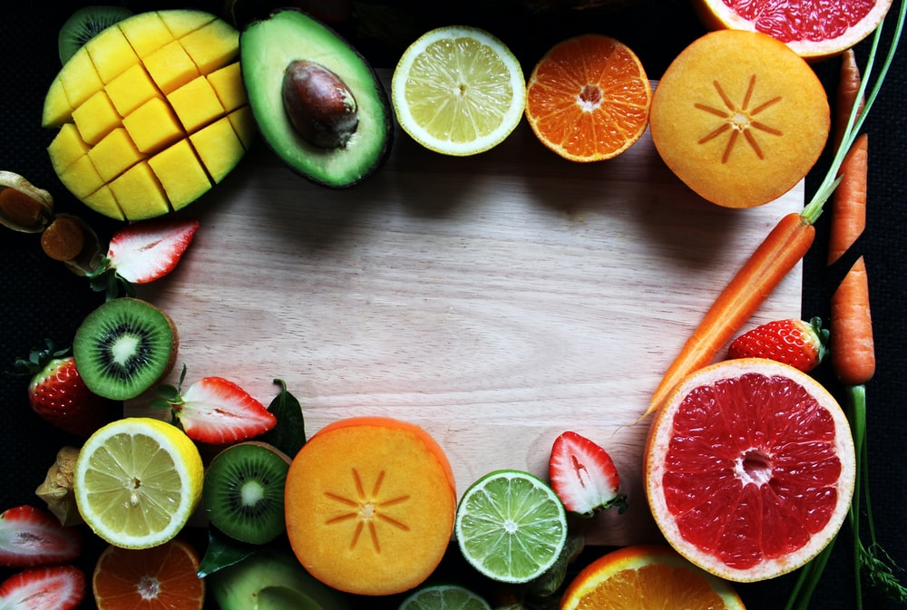

Jerk Chicken with Pinapple Slaw

Method

**Meet our Healthy Living Coordinator, Claire. Who is responsible for our newsletter and healthy living project.**

If you have any queries, would like to suggest a feature for our future newsletters, or would like support and advice around issues raised here, please contact Claire at [healthyliving@nortonhousingandsupport.org.uk](mailto:healthyliving@nortonhousingandsupport.org.uk)

**Recipe Of The Week**

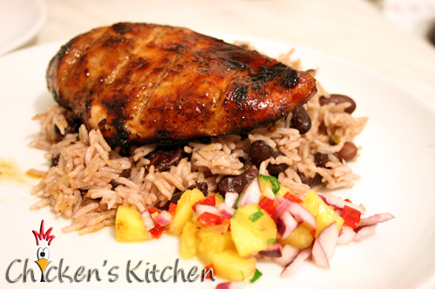

Ingredients

For pineapple slaw: combine bok choy, cabbage, and pineapple.

In a small bowl stir together vinegar and 1 teaspoon of brown sugar. Drizzle over bok choy mixture and toss to coat.

On a board, halve the chicken breasts lengthways, so they are half the thickness, and rub each piece with the jerk seasoning. wash hands well.

Grill on the rack of a covered grill directly over medium heat for 8 minutes, then turn and cook the other side for 8-12 minutes until chicken is done.

Transfer to a cutting board and slice. Serve chicken with pineapple slaw.

Healthy Living Tips

Serve on its own, with brown rice,

Or why not rub a ‘corn on the cob’ with a little jerk seasoning and roast for 30 minutes/200c as an extra tasty side dish?

3 heads baby bok choy, trimmed and finely sliced

100g red cabbage, thinly sliced/shredded

200g pinapple fingers, chopped into chunks

2 tbsp cider vinegar

1 tsp dark brown sugar

2 tsp jamacain jerk seasoning

2 chicken breasts