Beat the sugar cravings

Why not try these tactics to lower your sugar intake?

Eat something sweet with something healthy
- If you easily give in to your cravings, try balancing out an unhealthy treat with something nutritious like a handful of nuts or a piece of fruit.
Allow yourself a sugary treat – but only a small one
- Going completely cold turkey when it comes to sugar can be a miserable experience. Having a little bit of what you love is a good compromise, whether that’s one biscuit or a couple of squares of good quality chocolate. Just opt for lower calorie options where possible.
Have a glass of water
- If your mind is fixated on sweet snacks and your mouth is watering, have a cold glass of water.
Eat regular meals packed with protein and fibre
- As sugary foods tend to be eaten as snacks, one of the best ways to limit your intake is to simply avoid snacking! To do this, make sure you’re eating healthy, balanced meals regularly. Choose dishes which are high in fibre and protein as they will make you feel fuller for longer.
Go for a walk or run
- One of the best ways to halt a craving in its tracks is to take your mind off it! Heading outdoors for a brisk walk will not only take you out of temptation’s way, but also release happy hormones in the brain which could help you manage your craving!
Keen to cut out unhealthy sugars altogether?
There are many healthier products out there which give you the same delicious taste.
- Switching sugary fizzy drinks for flavoured water or no-added-sugar drinks.
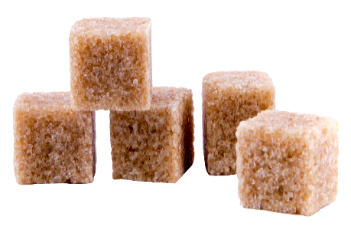
- Reducing the amount of sugar you add to hot drinks or cereal, or try a natural sweetener like Stevia.
- Buying low sugar or sugar-free versions of things like breakfast cereals, fruit spreads or tins of fruit.
- Sweetening dishes with fresh or dried fruit instead of sugar or honey.

