

Healthy Living Focus

Beat the cravings!

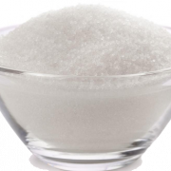

Healthy Living Goal

Plan ahead and aim eat at regular times, filling up on healthy wholesome food!

Top 5 craving tips

Reduce stress

Feeling stressed can result in us eating more calories than we need.

Try to find something you enjoy doing. Exercise is the perfect way to release happy hormones and beat cravings, and stress at the same time !

Social Distance- from the craving!

Try to keep a distance between you and the food you are craving.

* Remove them from the house
* Don’t buy them from the shops
* Go for a walk, the fresh air will help to clear your mind
* Have a shower or read a book to change your trail of thoughts

Changes to thoughts or the environment can help to beat the cravings

* Eat small, regular meals
* Avoid getting extremely hungry, especially before a trip to the supermarket
* Get plenty of sleep
* Drink lots of water
* Eat slowly to fully enjoy your meals

**What is a food craving?**

**‘A craving is an uncontrollable desire for a certain food, which is stronger than hunger and can take over your thoughts’**

Planning and Protein

* Plan your meals

Make a meal plan for the week. this will help to elimiate sponteniety and uncertainty- both of which can cause cravings for takeaways and junk food.

* Protien power

fill up on protein! Eating lots of lean meat, fish, eggs and lentils in your main meals is proven to reduce cravings by 60% and snacking by 50%.

Hello and welcome to this week’s healthy living focus, in this edition we are looking at ways to beat pesky food cravings. craving junk food is one of the biggest reasons people struggle to loose weight and keep it off, but with some simple tips and suggestions we can try to avoid and challenge the cravings, helping us to achieve a healthy body and mind.

* Visit <https://www.hollandandbarrett.com/the-health-hub/food-drink/how-to-beat-sugar-cravings/> to find out 6 ways to beat sugar cravings!

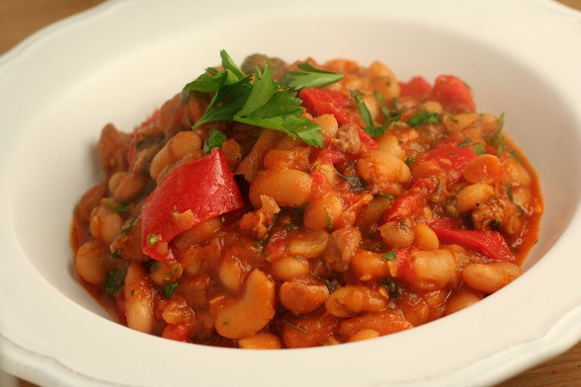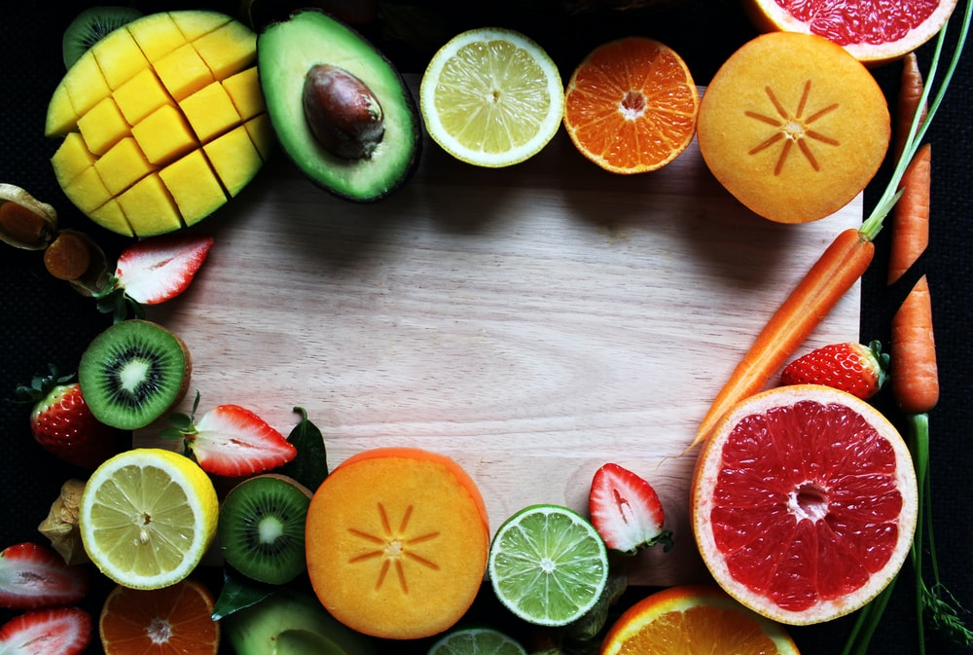

Healthy Living Tips

Don’t be put off by the long list of ingredients. This doesn’t mean extra work just extra flavours! This is a simple dish to put together with little washing up!

1. Heat the oil in a large, non-stick frying pan. Add the chicken and season with the pepper. Cook for 2 minutes while stiring.
2. Transfer the chicken to a plate, and add the onion, pepper, courgette and chorizo to the pan. Fry over a medium heat for 3 minutes, stiring often.
3. Add the wine, tomatoes, butterbeans, tomato purée, oregano, chilli flakes and chicken stock cube. fill the tomato tin with cold water, and add to the pan.
4. Bring the sauce to the boil, return the chicken to the pan and simmer for 8–10 minutes, or until the chicken is tender and cooked through and the sauce has thickened.
5. Meanwhile, cook the rice for 10–12 minutes. after 5 minutes add the green beans to the pan, boil for the remaining 5-7 minutes, and drain when both are cooked and tender. serve on a plate along with the chicken and sauce.
6. Garnish with parsley and enjoy!

Method

Ingredients

1 tbsp extra virgin olive oil or spray oil

2 chicken breasts, sliced

1 onion, sliced

1 yellow pepper, deseeded and chopped

1 courgette, sliced

100g chorizo, sliced

100ml red wine (optional)

400g tin chopped tomatoes

400g tin butter beans, drained and rinsed

1 tbsp tomato purée

1 tsp dried oregano

½ tsp dried chilli flakes

1 chicken or veg stock cube

160g/5¾oz long-grain rice

175g green beans, trimmed

parsley, to garnish

ground black pepper

Spanish Chicken with Rice

**Meet our Healthy Living Coordinator, Claire. Who is responsible for our newsletter and healthy living project.**

If you have any queries, would like to suggest a feature for our future newsletters, or would like support and advice around issues raised here, please contact Claire at [healthyliving@nortonhousingandsupport.org.uk](mailto:healthyliving@nortonhousingandsupport.org.uk)

**Recipe Of The Week**