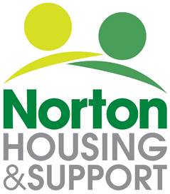

Recruitment Equality and Diversity Monitoring

Please note that this information will be kept separately from your application or CV

Norton Housing strives for high standards, both as an employer and as a provider of services. In so doing, we recognise the need to encourage diversity and wholeheartedly support a policy of equal opportunities in all areas of our work and responsibilities.

The purpose of this form is to help us monitor how well we are doing in attracting people from as wide a range of backgrounds as possible. The information will remain confidential and will only be used for statistical purposes.

As a result of this monitoring, we may find we need to make changes to the way in which we operate or the services we offer.

Please complete the form as fully as you feel able. However, if you do not want to answer a particular question, please tick this option.

Thank you.

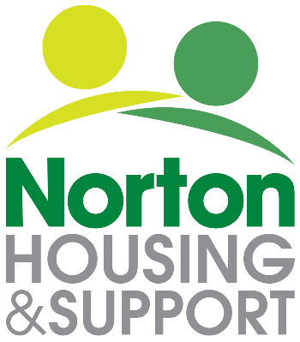

Equality and Diversity Monitoring Form
please tick the appropriate box

Your Age  ☐Under 25  ☐ 25-34  ☐ 35-44  ☐ 45-54  ☐ 55-64  ☐ 65+  ☐ Prefer not to say |  | Your Gender Identity:  ☐ Male  ☐ Female  ☐ Non binary  ☐ Other / prefer to self-describe (please state below)  Prefer not to say  ______________________
Is your gender identity the same as the sex you were assigned at birth?

☐ Yes
☐ No
☐ Prefer not to say

Your Sexual Orientation

☐ Bi-Sexual  ☐ Heterosexual / straight  ☐ Other / prefer to self- ☐ describe (please state below  ____________________________ | ☐ Gay man  ☐ Lesbian / gay woman  ☐ Prefer not to say

Disability

Do you consider yourself to have a disability or health condition?
The Disability Act 2010 defines a person as disabled if they have (or have had) a physical or mental impairment, which has a substantial and long term (i.e. has lasted or is expected to last at least 12 months) adverse effect on the person’s ability to carry out normal day-to-day activities.
☐ Yes
☐ No
☐ Prefer not to say

Cont..

If you have answered yes, please indicate the type of impairment which applies to you. People may experience more than one type of impairment.

☐ Mental health condition such as schizophrenia, bipolar disorder or depression
☐ Physical impairment such as mobility issues which may mean using a wheelchair or crutches.
☐ Sensory impairment such as being blind/ having a visual impairment or deaf / hearing impairment.
☐ Learning disability such as Down’s syndrome or dyslexia or cognitive impairment such as autism or a head injury.
☐ Long standing illness or health condition such as cancer, HIV, diabetes, chronic heart disease or epilepsy.
☐ Other (please describe below)
☐ Prefer not to say

________________________________________________________

Your Ethnic Group:  Ethnic origin is not about nationality, place of birth or citizenship. It is about the group to which you perceive you belong. Please tick the appropriate box  ☐ Prefer not to say  Asian / Asian British  ☐ Bangladeshi  ☐ Pakistani  ☐ Indian  ☐ Chinese  ☐ Other Asian origin (specify below if you wish)  …………………………………...........  ………………………………………..  Black / African / Caribbean Black British  ☐ Caribbean  ☐ African  ☐ Black other (specify below if you wish)  …………………………………...........  Your Religion or Belief  ☐ Baha'i  ☐ Buddhism  ☐ Christianity (including all denominations e.g. Anglican, Catholic, Presbyterian, Methodist and Baptist)  ☐ Hinduism  ☐ Jainism  ☐ Judaism  ☐ Islam  ☐ Sikhism  ☐ No religion or belief  ☐ Other (Specify below if you wish)  ☐ Prefer not to say  …………………………… | Mixed  ☐ White and Asian  ☐ White and Black African  ☐ White and Black Caribbean  ☐ Any other mixed background, (specify below if you wish)  …………………………………...........  ………………………………………..  White  ☐ British  ☐ English  ☐ Irish  ☐ Northern Irish  ☐ Scottish  ☐ Welsh  ☐ Gypsy or Irish Traveller  ☐ White other (specify below if you wish)  …………………………………...........  Other Ethnic Origin:  ☐ Any other ethnic background (specify below if you wish)  …………………………………...........

