

**Healthy Living Focus**

**Alcohol**

**Hello and welcome to the healthy living focus, in this edition we are going to take a look at Alcohol. With a focus on understanding units, how to avoid gaining weight from excess drinking, tips to cut down, and the benefits of doing so. As well as what to do if you need help to control or stop drinking altogether.**

**Liquid Calories!**

**Did you know a glass of wine can contain as many calories as a bar of chocolate, and a pint of lager has about the same number of calories as a packet of crisps? So, if you are trying to maintain a healthy weight, or lose weight it is important to focus on what you drink as well as eat!**

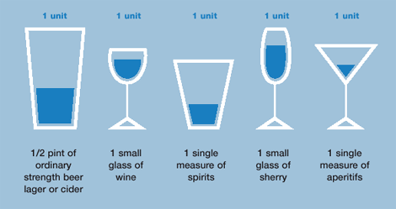



* **men and women are advised not to drink more than 14 units a week.**

**Drinking 5 pints of lager each week adds up to 44,200kcal over a year, the same as 221 doughnuts!**

**Tips to avoid weight gain from alcohol**

* **Alternate an alcoholic drink with a glass of water.**
* **Don’t drink on an empty stomach! Have a healthy meal before an alcoholic drink and if you do reach for snacks while drinking, choose a healthier option.**
* **Pace yourself by taking small sips**
* **Opt for diet mixers instead of calorific sugary mixers.**
* **Add a splash of soda water to wine to help units last longer.**

**Tips to cut down**

* Opt for a smaller glass, try a bottle of beer instead of a pint
* Cut back a little each day, making each day a success!
* swap strong beers or wines for ones with a lower strength (ABV in %). You'll find this information on the bottle.
* Take a break- have several alcohol free days each week.

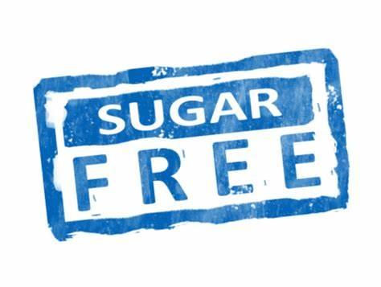

**Realising you have a problem with alcohol is the first big step to getting help.**



You may need help if:

* you often feel the need to have a drink
* you get into trouble because of your drinking
* other people warn you about how much you're drinking
* you think your drinking is causing you problems

**Benefits of cutting down**

* **Better sleep and more energy.**
* **Better long term physical health, for example, a healthier heart!**
* **Improved mental health, for example, reduced anxiety.**
* **Less weight gain**
* **Lengthens your lifespan**

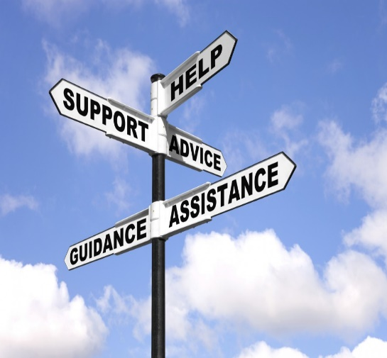

**If you feel you need a long-term plan to stay in control or completely alcohol free, getting the right support can be crucial to success. Ask a GP about what longer-term support is available in your area, or get in touch with one of these recommended services.**

**Drinkline,** a national alcohol helpline**: 0300 123 1110**

**visit AA to find a local support group near you**

[**Alcoholics Anonymous - Great Britain (alcoholics-anonymous.org.uk)**](https://www.alcoholics-anonymous.org.uk/)

**Al-Anon,** for those effected by someone else’s drinking**: 0800 0086 811**

**Expert Support**

**Recipe of the week!**

Zesty Salmon Pasta

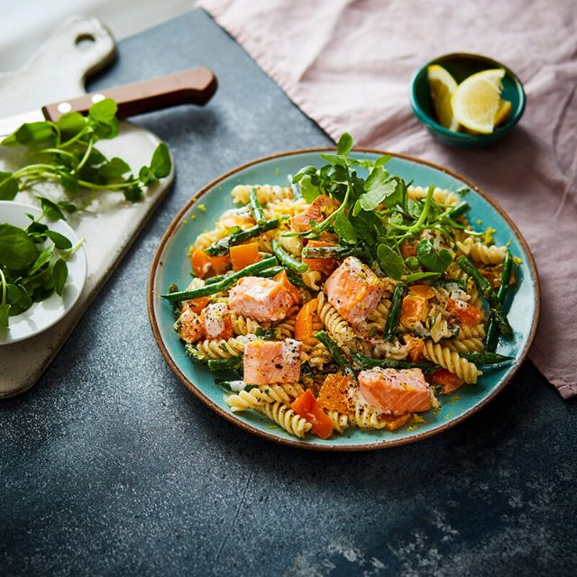

Ingredients

* 500g dried fusilli pasta
* Low-calorie cooking spray
* 4 skinless and boneless salmon fillets, cut into bite-size chunks
* 2 peppers (any colours), deseeded and chopped
* 1 garlic clove, crushed
* 300g green beans, trimmed and halved
* 100g fat-free natural fromage frais
* 1 large unwaxed lemon, zested and cut into wedges
* Small bag of watercress, a few sprigs reserved, the rest chopped

1. Cook the pasta according to the pack instructions, then drain and return to the pan, reserving 100ml of the pasta cooking water.
2. Spray a frying pan with low-calorie cooking spray and place over a high heat. Add the salmon chunks and cook for 1-2 minutes or until just cooked, stirring occasionally. Transfer to a plate.
3. Add the peppers, garlic and green beans to the frying pan and cook for 6-8 minutes or until tender and lightly charred. Add to the salmon cubes and mix gently.
4. Toss the salmon mixture through the pasta and stir in the fromage frais, lemon zest, chopped watercress and as much of the pasta water as you need to make a sauce. Divide between plates or shallow bowls, scatter over the watercress and serve with lemon wedges to squeeze over. Enjoy!



**Meet our healthy living coordinator, Claire. Who is responsible for our newsletter and healthy living project.**

If you have any queries, would like to suggest a feature for our future newsletters, or would like support and advice around issues raised here, please contact Claire at [healthyliving@nortonhousingandsupport.org.uk](mailto:healthyliving@nortonhousingandsupport.org.uk)