

**Healthy Living Focus**

**Stop smoking!**

**Hello and welcome to the healthy living focus, Stop Smoking edition. We all know that smoking is bad for our health, but just how bad is it? Here we will look at the issue of smoking, how its effects our health and wellbeing, the benefits of giving up smoking, and where to go for help and support with quitting.**

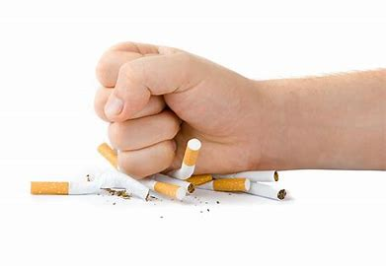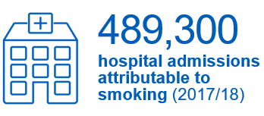

**Just how bad is smoking for our health?**

**Around 14% of the population are smokers. It can lead to serious conditions such as heart disease, lung cancer, and chronic bronchitis. As well as contribute to poor mental health, a reduced life expectancy and cause health problems for those around you who breathe in second hand smoke**.

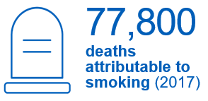

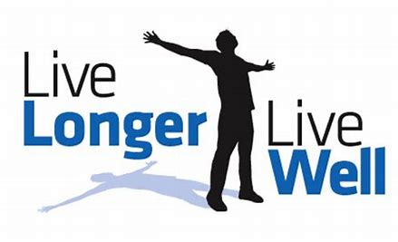

**People who quit smoking by the age of 30 add 10 years onto their life. People who kick the habit at 60 add 3 years to their life.**

**Smoking and mental health**

**It is a common belief that smoking helps to reduce stress, this is not true, and here is why. Smoking cigarettes interferes with chemicals in the brain. When smokers have not had a cigarette for a while, the craving makes them feel irritable and anxious. In fact, it is the effect of smoking itself that is likely to have caused the anxiety in the first place. Cutting out smoking does in fact improve mood and reduce anxiety.**

**Benefits of quitting**

* Breathe more easily.
* Boosted immune system.
* Have more energy to exercise.
* Benefit from lower stress levels.
* Better dental health.
* Protect your loved ones from passive smoke.
* Live longer!

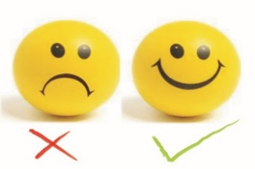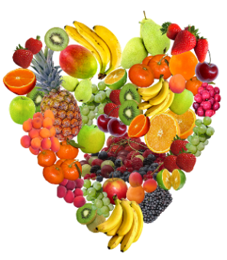

**Tips to quit for good**



**Think positive**! You may have tried to quit before, but do not let that put you off! Use your past experience to help you be successful this time around.

**Make a plan!** Set a date when you aim to quit by, using the “not a drag rule”, so that each time you feel the craving, tell yourself “I won’t even have a single drag” until the feeling passes. This will feel like a huge achievement!

Benefits of quitting on mental health

* Anxiety, depression, and stress levels are lower.
* Quality of life and mood improve.
* Feelings of calm and positivity.
* The dosage of some medicines used to treat mental health conditions may be reduced.

**Change your diet!** Some foods like cheese, fruit and vegetables have been proven to make cigarettes less appealing, as have certain drinks such as water and juice. So making simple changes such as swapping a fizzy drink to a fruit juice could affect the need to reach for a cigarette.

**Take up a new hobby**. How about crocheting or get crafty by making your own greeting cards or a scrapbook?

**Get moving!** Going for a short walk can help your brain to produce anti-craving chemicals.

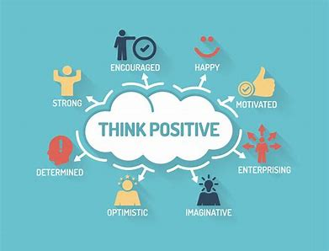

**Expert Support**

* Contact your GP. This is especially important if you have medical conditions or are taking medications.
* Call Leicester Stop Smoking Service on **0116 454 4000**
* Call NHS Quit Ready Leicester on **0345 646 666**

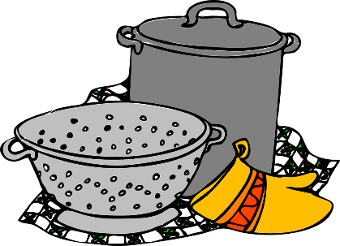



Three Veg Mac and Cheese





Ingredients

* 150g [butternut squash,](https://www.bbcgoodfood.com/glossary/butternut-squash-glossary) cut into chunks
* 300g penne pasta (use wholemeal pasta for extra fibre)
* 40g [butter](https://www.bbcgoodfood.com/glossary/butter-glossary)
* 1 [small leek,](https://www.bbcgoodfood.com/glossary/leek-glossary) finely sliced
* 25g [flour](https://www.bbcgoodfood.com/glossary/flour-glossary)
* 600ml [milk](https://www.bbcgoodfood.com/glossary/milk-glossary)
* 100g [frozen peas](https://www.bbcgoodfood.com/glossary/peas-glossary)
* 175g [mature Cheddar cheese](https://www.bbcgoodfood.com/glossary/cheddar-glossary)
* 1 slice day-old brown bread, blitzed into crumbs

Method

1. Heat oven to 200C/fan 180C/gas 6. Put the butternut squash in a steamer over boiling water. Steam for around 15-20 minutes or until tender. Drain and then blitz in a food processor until smooth.
2. Cook the pasta according to the pack instructions.
3. Heat the butter in a medium saucepan, add the leek and cook for 2 minutes. Stir in the flour and cook for 1-2 minutes more. Take the pan off the heat and stir in the butternut squash, then 125g cheese.
4. Stir the pasta into the sauce and transfer to an ovenproof dish. Sprinkle over the remaining cheese and breadcrumbs. Bake for 20 minutes or until golden and bubbling. Serve with a green side salad.



**Meet our healthy living coordinator, Claire. Who is responsible for our newsletter and healthy living project.**

If you have any queries, would like to suggest a feature for our future newsletters, or would like support and advice around issues raised here, please contact Claire at [healthylivingnorton@icloud.com](mailto:healthylivingnorton@icloud.com)