

**Healthy Living Focus**

**OBESITY**

**Hello, and welcome to healthy living focus: Obesity. Here, we aim to talk about Obesity, what it means for our health, and how to change our lifestyle to prevent obesity and lose unnecessary weight. Using recommended tips and suggestions for a healthy diet, to enjoy being active, and cook up a storm in the kitchen using tasty fresh ingredients.**

**What is Obesity?**

**How do I know if I am obese?**

The most widely used method to check if you are a healthy weight is body mass index (BMI).

BMI is a measure of whether you are a healthy weight for your height. There are many free tools online to calculate BMI.

* Obesity describes a person who's very overweight, with a lot of body fat
* It is a common problem in the UK that affects around 1 in every 4 adults and around 1 in every 5 children.

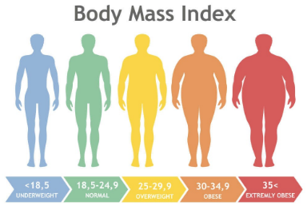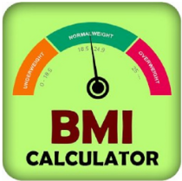

Would you like help in calculating your BMI? Contact Claire, our healthy living coordinator, who can help you with this! Be assured all information will be treated with the strictest confidentiality.

**Tackling obesity**- becoming a healthy weight!

There is no quick fix to lose weight. The two best ways to do this are to eat a **healthy diet**, and to **exercise more**. This takes determination, motivation, and small consistent changes to daily routines!

Follow a weight loss guide, such as NHS live well, which provides a 12 week guide for weight loss, free of charge.

<https://www.nhs.uk/live-well/healthy-weight/start-the-nhs-weight-loss-plan/>

Obesity can cause many problems, from serious conditions, to difficulty completing daily activities, just some of which are listed here!

**Risks of Obesity…**

* Type 2 diabetes
* Coronary heart disease
* Certain types of cancer
* Stroke
* Joint and back pain
* Breathlessness and snoring
* Low confidence and low self esteem

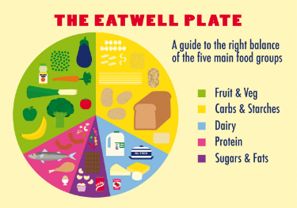

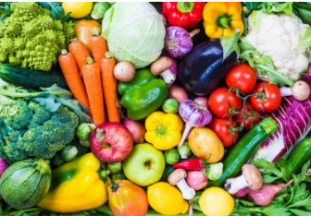

Top tip: Aim to fill your plate with ⅓ vegetables with every meal!

**Eat a healthy diet**

* Eat regular meals, this helps to avoid snacking between meals.
* Eat plenty of fruit and vegetables; these are low in calories and full of goodness.
* Eat lots of fibre, this keeps you fuller for longer.
* Drink plenty of water, staying hydrated is important.
* Read food labels, opting for foods lower in calories, fat, sugar, and salt.
* Cut down on alcohol, swapping for sugar free drinks instead.



**Exercise more**

There is no better way to feel energised, boost your mood and lose weight!

* Find an activity you enjoy and build it into your daily routine, how about a 30 minute walk, a bicycle ride, or an online active class, anything from dance to yoga.
* Put the days and times you plan to exercise onto your calendar, and feel proud each time you achieve what you set out to do!
* Start small, building up to longer sessions as you increase your energy levels. For example...

Week 1 = 15 minutes walking, 3 x a week

Week 2 = 15 minutes walking, 5 x a week

Week 3= 30 minutes walking, 5 x a week

Week 4 = 45 minutes walking, 5 x a week

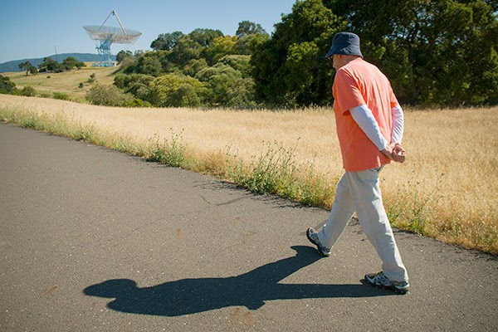

**Recipe of the week!**

This chicken dish is full of flavour, and goes well with so many tasty sides. It comes in at just 184 calories per serving.

Chicken with Harissa & Tomatoes

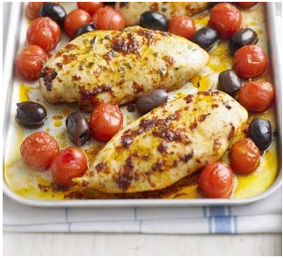

Ingredients (serves 4)

* 4 skinless chicken breasts
* 2 tsp harissa
* 1 tsp olive oil
* 1 tsp dried oregano
* 250g pack cherry tomatoes
* handful olives



Method

1. Heat oven to 200C/fan 180C/gas 6. Put the chicken into a medium roasting tray, and then rub with the harissa, oil and oregano.
2. Cover with foil and roast for 5 minutes, then remove the foil and add the cherry tomatoes and olives to the tray. Roast for 10 minutes more until the tomato skins start to split and the chicken is cooked through. Serve with one of the below, and enjoy!

* A toasted wholemeal pitta bread
* A serving of wholemeal rice
* Boiled new potatoes

Add a mixed salad with leaves, cucumber, spring onions, chopped pepper and feta cheese for extra filling power!



**Meet our healthy living coordinator, Claire. Who is responsible for our newsletter and healthy living project.**

If you have any queries, would like to suggest a feature for our future newsletters, or would like support and advice around issues raised here, please contact Claire at [healthylivingnorton@icloud.com](mailto:healthylivingnorton@icloud.com)