

**Healthy Living Focus**

**Diabetes**

Hello, and welcome to our new focus newsletter. This week we will be focusing on diabetes.

Whether you have been diagnosed with diabetes, at risk from diabetes, or just interested in learning a bit more about the condition, this newsletter is for you!

Here we aim to give you an overview of diabetes, information about living with diabetes, and a yummy recipe suitable for people living with diabetes.

**What is diabetes?**

**Diabetes is a complicated condition and there are many different types of diabetes. The two most common forms of diabetes are type 1 and type 2, which are different but both equally as serious. Diabetes is a serious condition where your blood glucose level is too high.**

**Type 1**: Your body doesn’t make any insulin at all.

**Type 2**: Your body can make insulin, but it doesn’t work properly, or you don’t produce enough of it.

**The common symptoms of diabetes**

● Going to the toilet a lot, especially at night.

● Being really thirsty.

● Feeling more tired than usual.

● Losing weight without trying to.

● Genital itching or thrush.

● Cuts and wounds take longer to heal.

● Blurred vision.

**How can I keep myself safe?**

If you’ve been diagnosed with diabetes, keeping an eye on your blood sugar level is a good way to keep yourself safe.

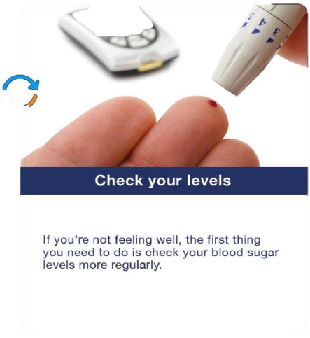

Type 2 diabetes is different for everyone, but your levels should range somewhere between 4-7 mmol/l and up to 8.5 mmol/l one or two hours after a meal.

👨If your levels are often high you need to speak to your GP or use the NHS 111 online service. Always talk to your doctor if you have any worries or concerns.

**Let’s look at the signs and symptoms of high blood sugar…**

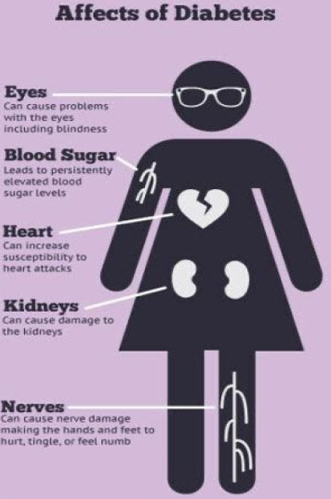

● Feeling thirsty.

● Passing urine frequently.

● Blurred vision.

● Feeling tired.

If you experience one or more of these symptoms, you may need to help your blood sugar levels return to normal.

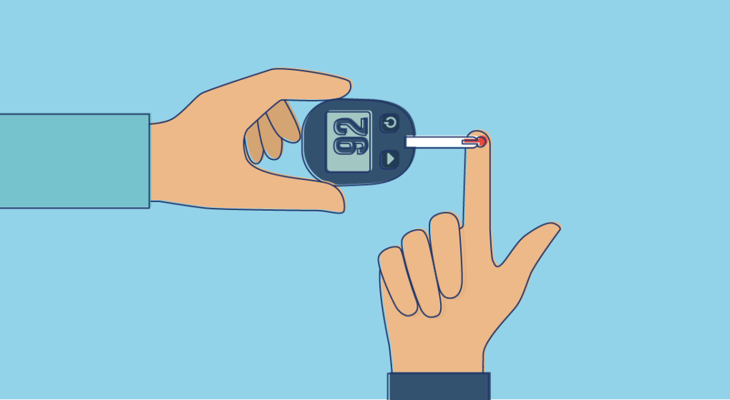

Here are two ways to do that!

✅drink water and stay hydrated

✅take your insulin if prescribed to do so.

If someone with diabetes is having a hypo and is conscious, they should eat or drink something fast acting and sugary such as a small glass of fruit juice, a sugary fizzy drink or a teaspoon of sugar.

Now we know that diabetes is a difficult condition to understand, and some people may experience episodes of low blood sugar, known as ‘hypos’.

Symptoms of this may include

✅sweating

✅blurred vision

✅loss of concentration

✅feeling confused and drowsy.

Maintaining blood sugar in the long term: *healthy eating!*

✅ Eat lots of fibre! Fibre is found in vegetables and whole grains such as brown bread and Weetabix.

✅avoid processed foods, such as fast food and ready meals.

✅eat a healthy diet with plenty of lean meat, fruit, nuts, fish and eggs.

**Do not ignore the symptoms of diabetes. These are just some of the serious affects diabetes can have.**

**If you have any concerns always contact your GP or call 111.**

**There is good news!**

You can reduce your risk of developing type 2 diabetes by:

1. **Healthy eating** -There is no such thing as a 'diabetic' diet or 'diabetic' recipes. See our top tips for healthy eating with diabetes, or try out our recipe of the week for some inspiration.

2. **Moving more-** this doesn’t have to be going to the gym! Any movement is great for creating a healthy lifestyle, whether that is a walk around the park, an online workout, gardening, housework or dancing around the kitchen to your favourite music!

3. **Losing weight** - if you're carrying extra weight. This can be done by healthy eating and moving more, but it takes time by making small, consistent changes!

Set small and realistic goals. How about cutting down on takeaways, increasing the fruit and vegetables in your diet, or planning a healthy family dinner?

*Making small manageable changes means you are more able to stick with a new healthier lifestyle, and look forward to a positive, healthy future!*

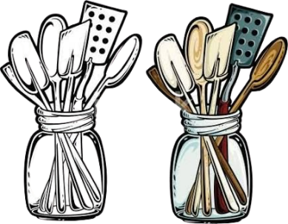

**Recipe of the week!**

This is a great diabetic friendly recipe that can be enjoyed by everyone. Packed with lean meat and vegetables, and freshly cooked in one pot!

**CHICKEN AND CHORIZO JAMBALAYA**



Ingredients

* 1 tbsp. olive oil
* 2 chicken breasts, chopped
* 1 onion, diced
* 1 red pepper, thinly sliced
* 2 garlic cloves, crushed
* 75g chorizo, sliced
* 1 tbsp. Cajun seasoning
* 250g long grain rice
* 400g can plum tomato
* 350ml chicken stock

Method

1. Heat 1 tbsp. olive oil in a large frying pan with a lid and brown 2 chopped chicken breasts for 5-8 minutes until golden.
2. Remove and set aside. Tip in the 1 diced onion and cook for 3-4 minutes until soft.
3. Add 1 thinly sliced red pepper, 2 crushed garlic cloves, 75g sliced chorizo and 1 tbsp. Cajun seasoning, and cook for 5 minutes more.
4. Stir the chicken back in with 250g uncooked long grain rice, add the 400g can of tomatoes and 350ml chicken stock. Cover and simmer for 20-25 minutes until the rice is tender.

To add extra fibre, vitamins, and 1 of your 5 a day, serve with a simple side salad! Mix some lettuce leaves, with slices of cucumber, chopped tomato, peppers, spring onions, or grated carrot.



**Meet our healthy living coordinator, Claire. Who is responsible for our newsletter and healthy living project.**

If you have any queries, would like to suggest a feature for our future newsletters, or would like support and advice around issues raised here, please contact Claire at [healthylivingnorton@icloud.com](mailto:healthylivingnorton@icloud.com)