

**Healthy Living News**

*Health, Wellness, Recipes, and support!*

**Hello! Welcome to the 3rd edition of Healthy Living News. We hope you are enjoying reading our healthy living newsletters, trying out some of the suggested exercises and online sessions, as well as getting creative in the kitchen and cooking up a storm using our healthy and tasty recipes.**

**This week we would like to tell you about some fab outdoor exercise classes that are available, explain the best way of getting out and about in lockdown Leicester, and share yummy lunch ideas!**

Lockdown Leicester

We know that Leicester is still in an extended lockdown, but with caution we can safely enjoy the outdoor space that Leicester has to offer. Here are some tips to safely enjoy a walk and get those steps in.

●If you or anyone in your household is showing coronavirus symptoms, stay at home, and book a test.

●If meeting someone from another household, remember to keep 2 meters apart at all times.

● Be prepared! carry with you hand sanitising gel for use before and after eating, and even after touching high touch areas such as gates and benches.

● Aim to go out at a quieter time of day, such as early morning or later in the evening.

● Do not meet others in houses or gardens, unless they are part of your support bubble.

● Wash your hands as soon as you get home.

**Leicester Outdoor Fitness**

Let’s get exercise!

With restrictions slightly eased in the city of Leicester, certain exercise groups are starting up again, so why not get out in the fresh air and enjoy the August sunshine by booking onto a class with *Leicester Outdoor Fitness.*

● Weekly outdoor exercise sessions at Victoria Park, on Granville road

● A ten minute walk from the city centre!

● Socially distanced classes for your safety.

● Bookable via Facebook. Contact ‘Leicester Outdoor Fitness’ using Facebook messenger (see their logo) to book one of the sessions below.



Where to walk? Abbey Park...

**How about making the most of our wonderful city and taking a walk through Abbey Park.**

**Enjoy the riverside scenery, or stroll around the remains of the twelfth century Leicester Abbey.**

Abbey Park is easily accessible on foot from the city centre. There are also bus routes travelling from the city centre along Abbey Park Road, along the edge of the park. There are three car parks, accessible from Abbey Park Road and St Margaret’s Way.

Leicester Fitness Support!

We hope you enjoyed Heather's

Facebook Live workout

last week.

For those who missed the live session, see our Facebook page for a link to access this fab video in your own time!

Let’s talk Lunch!!

Store-cupboard Pasta salad

This pasta salad makes a quick and healthy lunch, it can be prepared up to 2 days before and stored in the fridge, so why not plan ahead and make enough for two yummy lunches!!

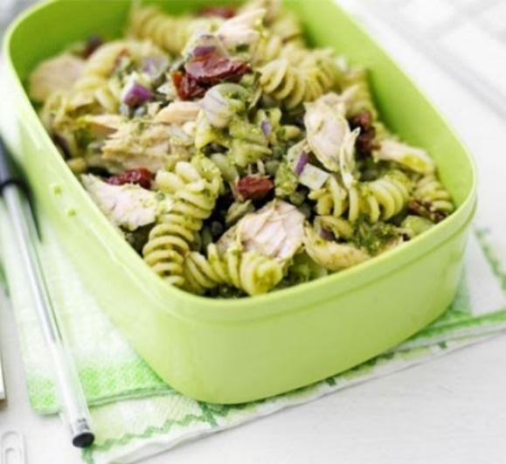

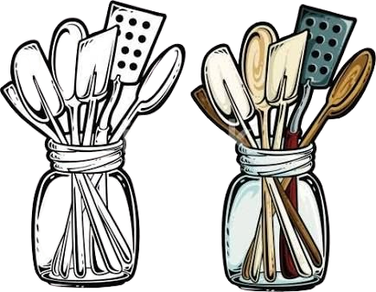

Ingredients (Makes 2 servings)

● 100g cooked pasta shapes

● ½ a small chopped red onion.

● 2tsp olive oil

● 185g tin tuna in brine or spring water, drained.

● A small tin of sweet corn, drained.

● 1 tbsp pesto, or 1tbsp light mayonnaise.

Method

1. In a mixing bowl, add in ingredients and mix together, coating the pasta salad in the pesto or light mayonnaise.
2. If making ahead, divide the pasta salad between two airtight storage containers, or bowls covered with foil/cellophane wrap.

ADD

You may add in any extra veggies you fancy, how about diced peppers, cucumber or cherry tomatoes? Have a look in the cupboard, what else could make a tasty addition?

SWAP

Not a fan of tuna? Why not swap this for slices of ham, cooked chicken or feta cheese!

Top Tips!

**Keep in touch - we would love to hear your suggestions! If there is a certain activity you fancy trying, or learning how to cook a certain dish, please get in touch!**

***Email:*** [***info@nortonhousingandsupport.org.uk***](mailto:info@nortonhousingandsupport.org.uk) ***or find us on Facebook: @NortonHousingAndSupport***

**[C:\Users\Fallon\AppData\Local\Microsoft\Windows\INetCache\Content.MSO\CF0B0484.tmp](https://www.facebook.com/NortonHousingAndSupport)[C:\Users\Fallon\AppData\Local\Microsoft\Windows\INetCache\Content.MSO\7CDED132.tmp](https://www.instagram.com/nortonhousing/)[C:\Users\Fallon\AppData\Local\Microsoft\Windows\INetCache\Content.MSO\C34F7810.tmp](https://twitter.com/NortonHousing)[C:\Users\Fallon\AppData\Local\Microsoft\Windows\INetCache\Content.MSO\3235689E.tmp](https://www.linkedin.com/company/norton-housing-and-support/)**